**Sprint 1 End-of-Sprint Progress Reporting**

**Top Deal Auto Website**

**Company:** Top Deal Auto Melbourne, Australia

**Software:** Car Selling Website

**Team name:** Prestige K/DA

**Team Members:**

| **Name** | **ID** | **Roles** |
| --- | --- | --- |
| Pham Duc Linh | 103792371 | Product Owner - BA |
| Pham Anh Vu | 103806447 | Solutions, IT Architect |
| Nguyen Thanh Dat | 103804881 | Project Manager - Scrum Master |
| Tran Tuan Nam | 103792643 | Lead Developer (BE) |
| Phung Xuan Tung | 103792054 | Lead Developer (FE) |

**Tutorial class:** Fri 1:00 PM DT7.2

**Tutor’s Name:** Dr. Pham Thi Kim Dzung

# Task board Reporting

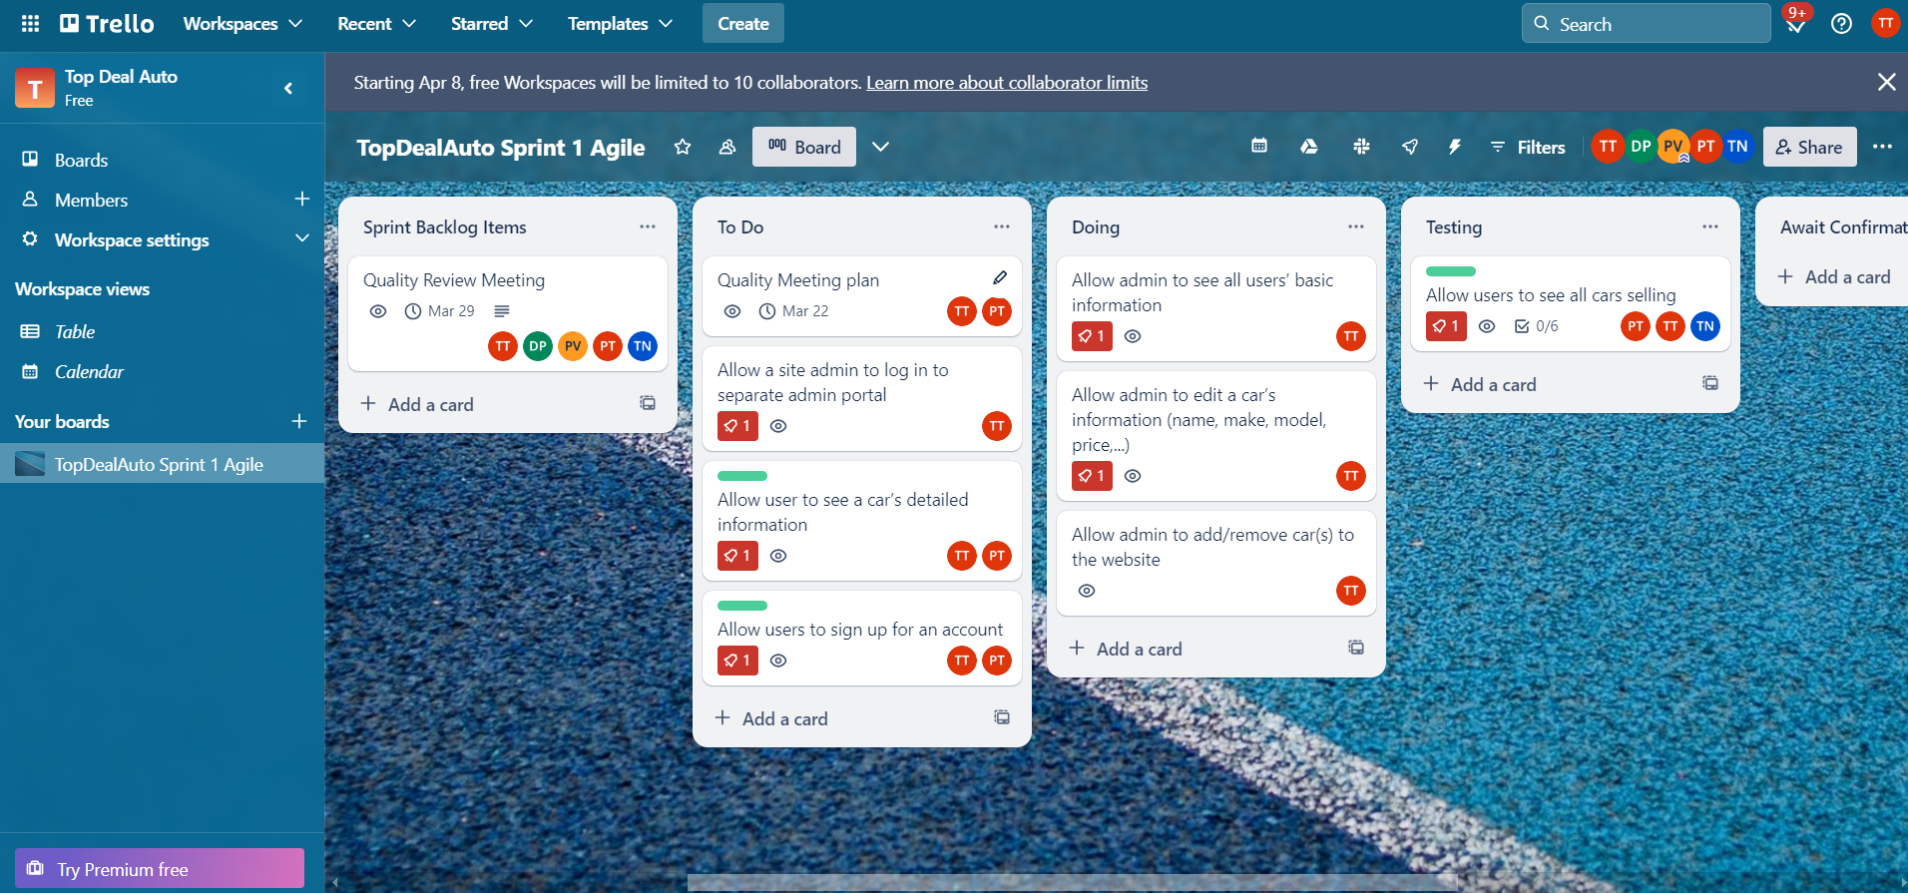

**Day 6**

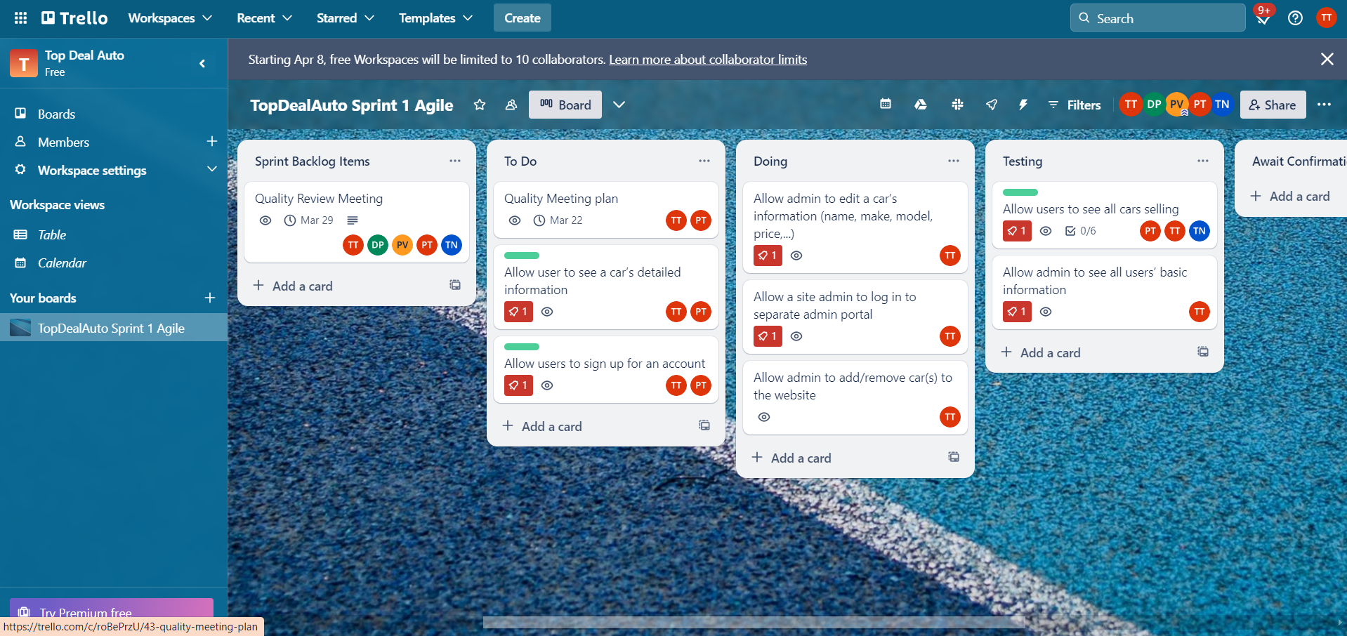

**Day 7**

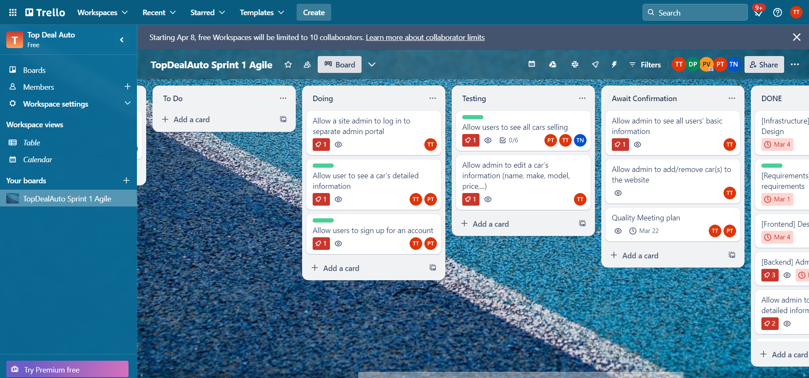

**Day 8**

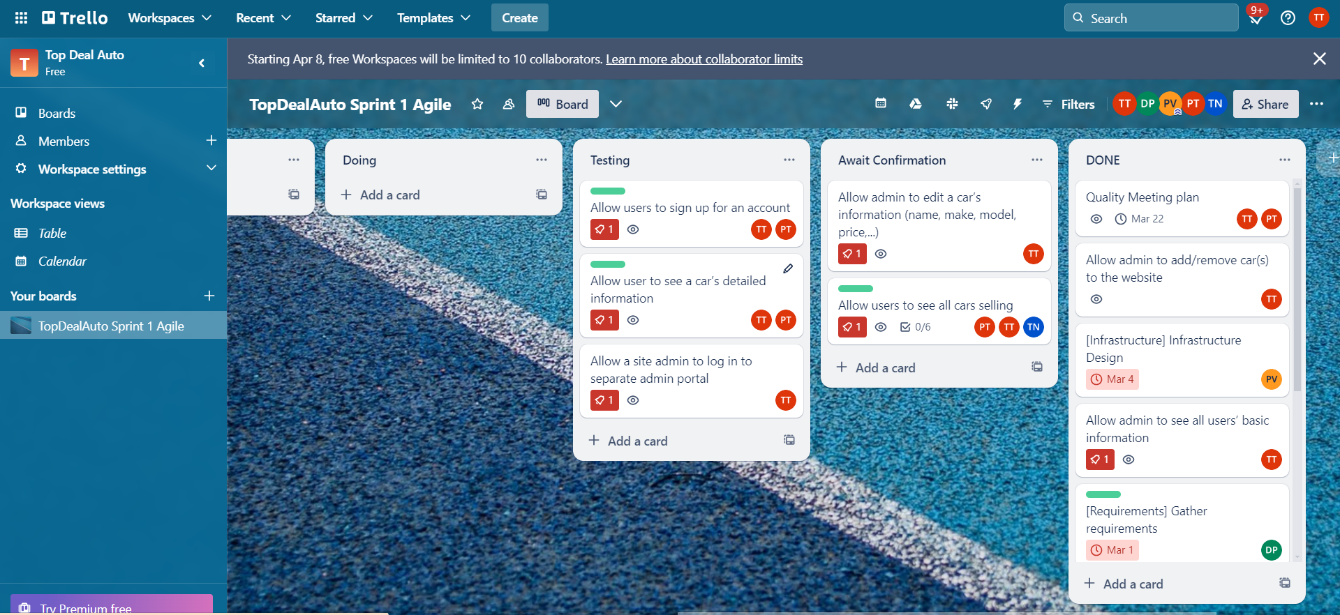

**Day 9**

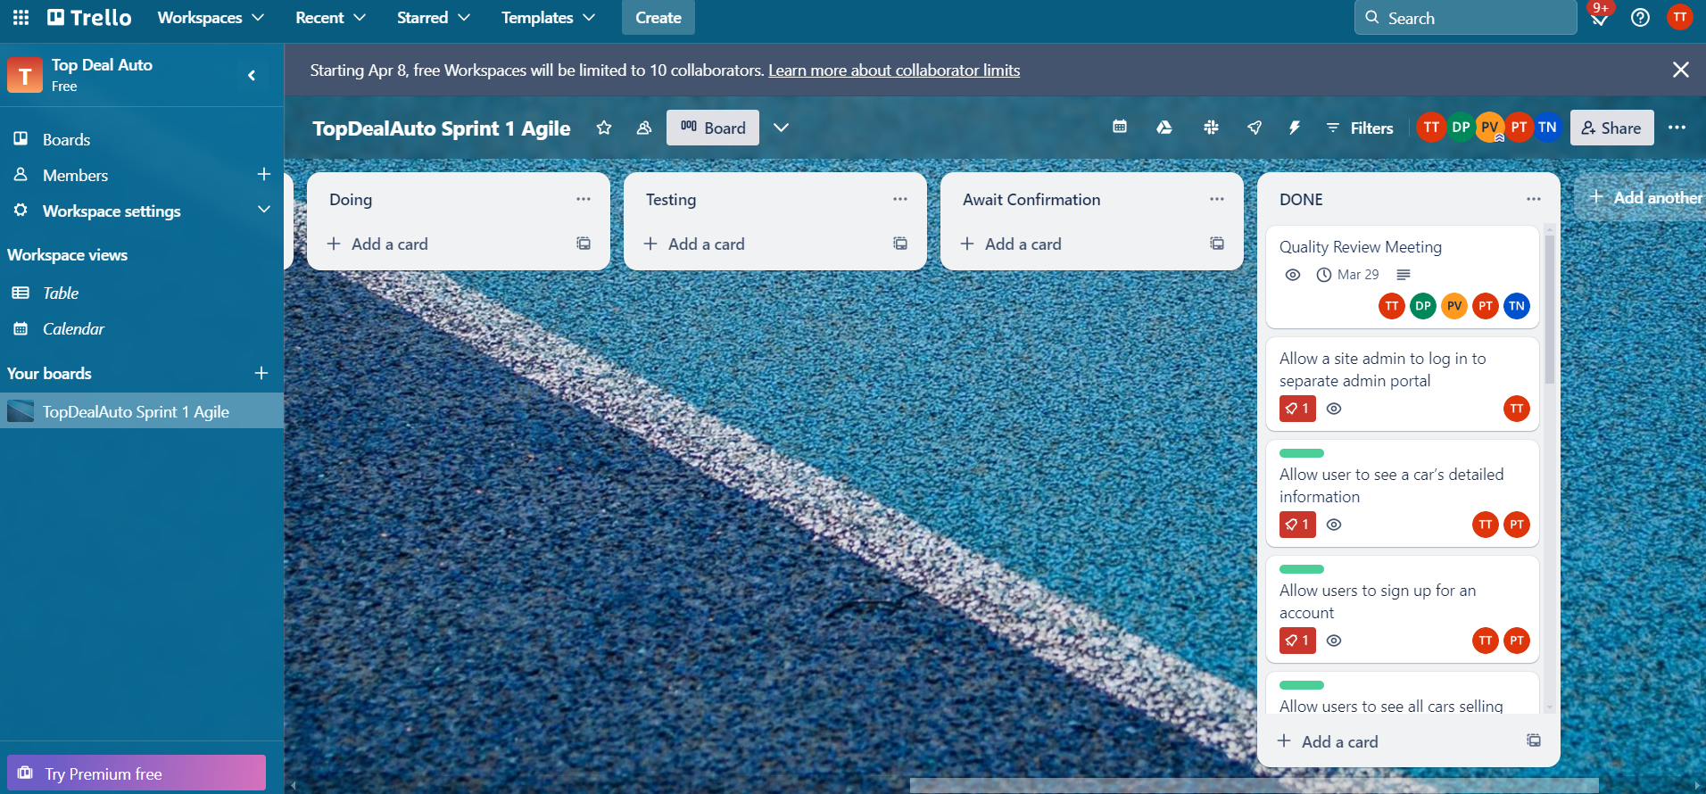

**Day 10**

# Burn-down Chart Reporting

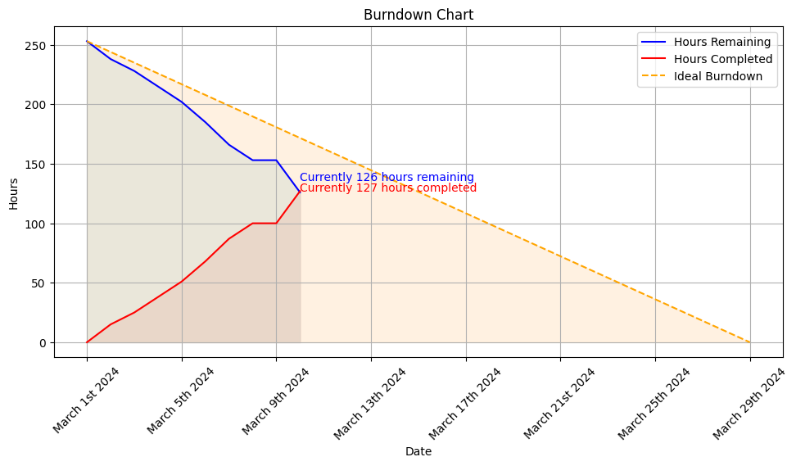

**Day 6**

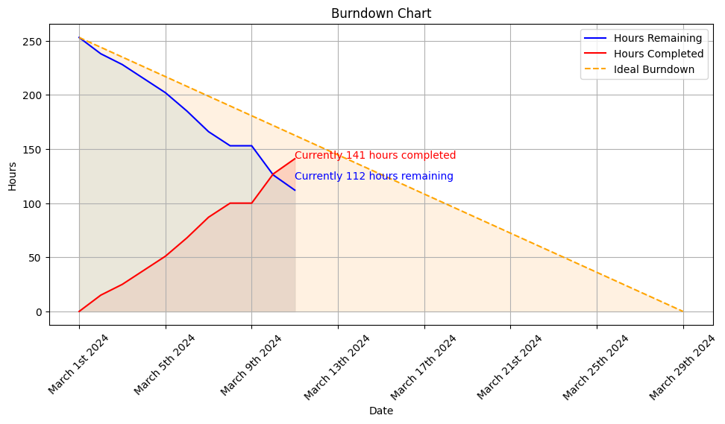

**Day 7**

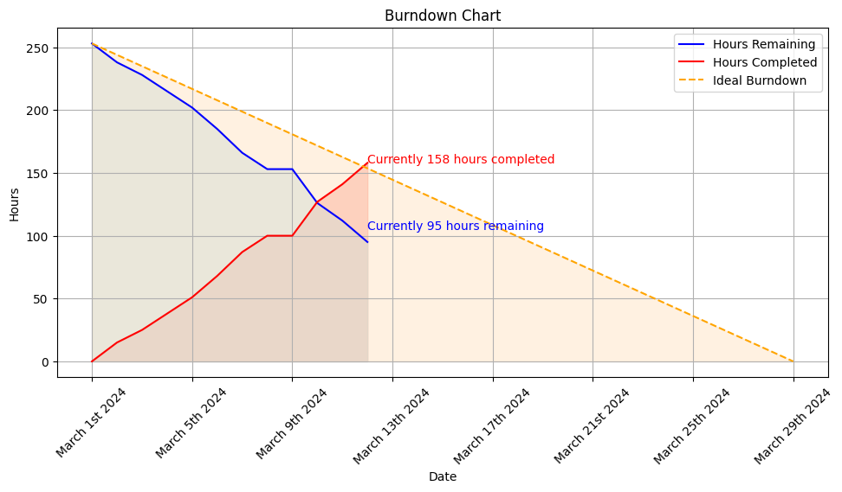

**Day 8**

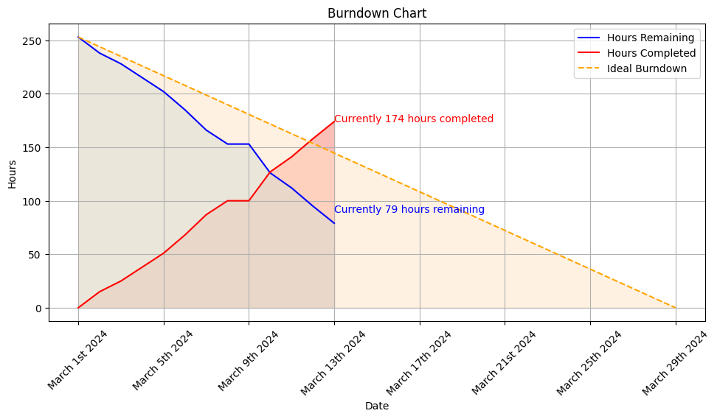

**Day 9**

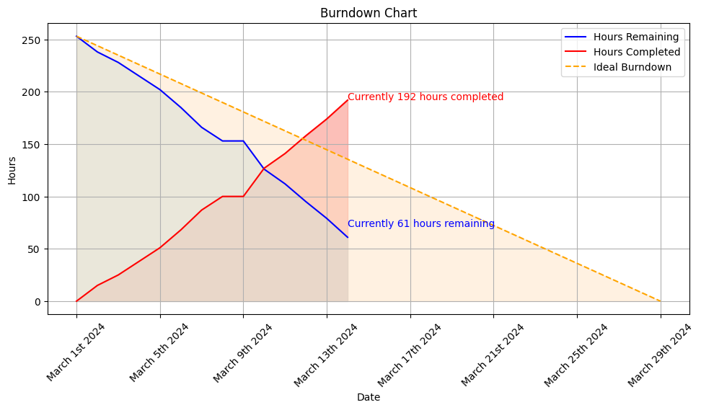

**Day 10**

# Project Repository Reporting

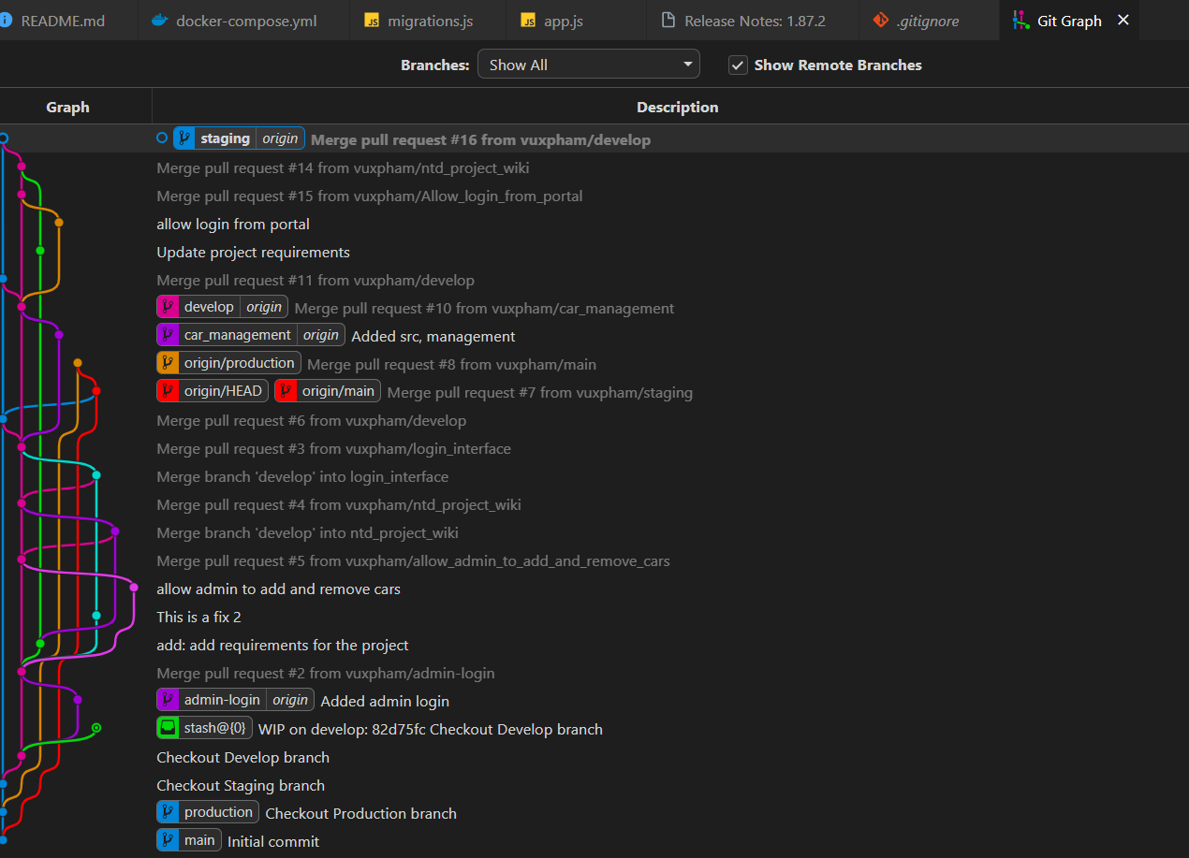

**Day 6 (merge BE to staging)**

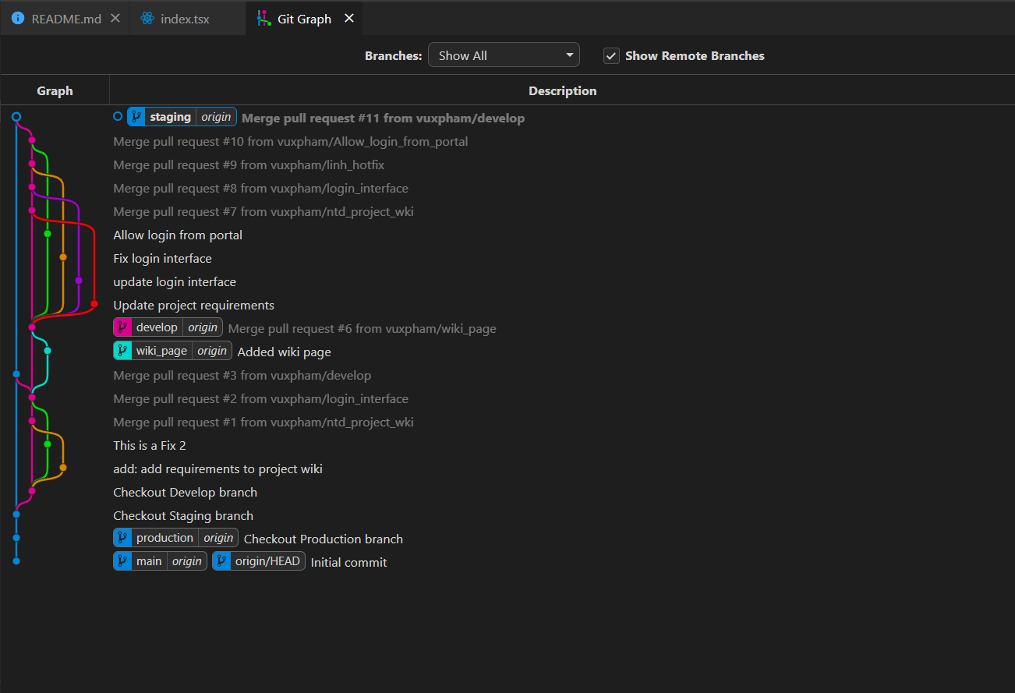

**Day 7 (merge FE to staging)**

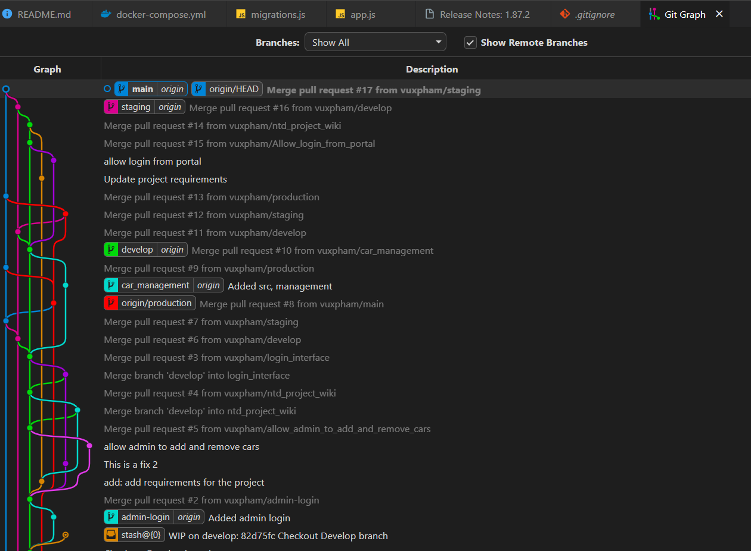

**Day 8 (merge BE to production)**

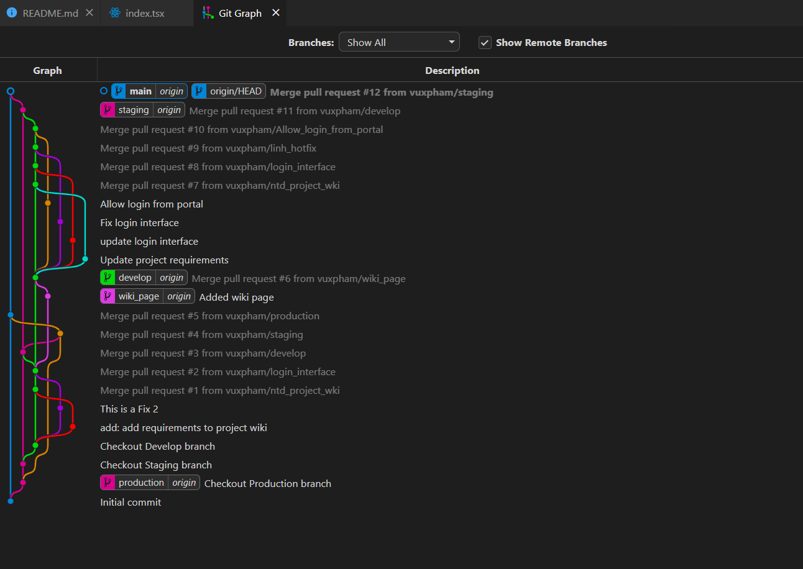

**Day 9 (merge FE to production)**

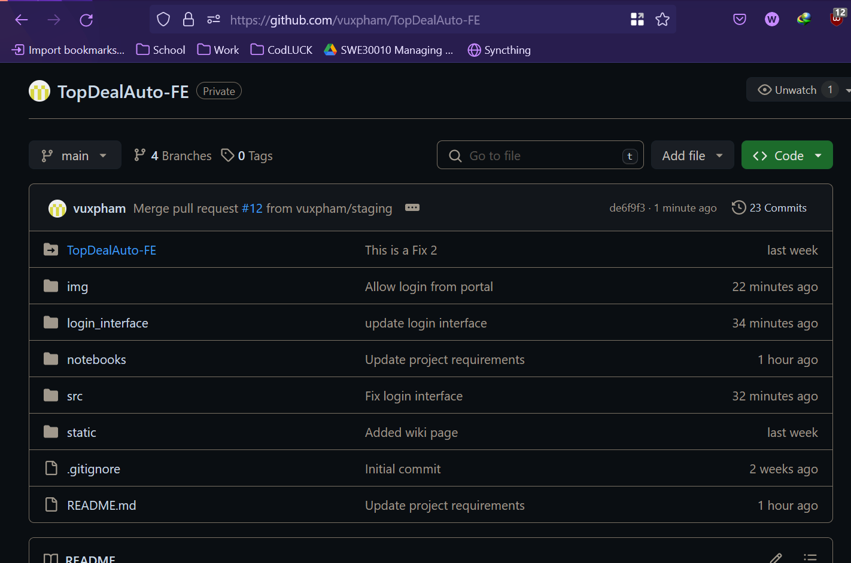

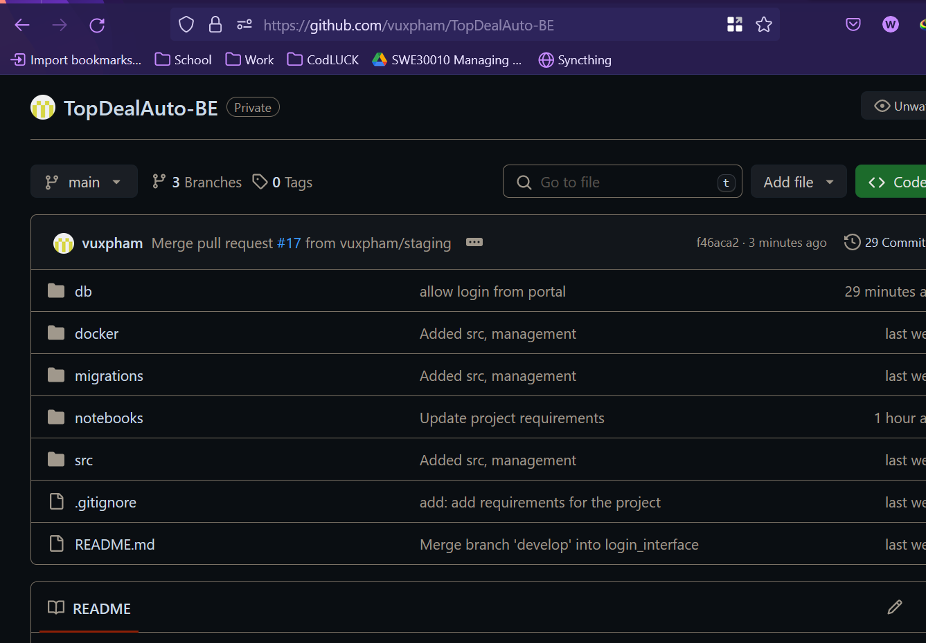

**Day 10 (repo)**

# Group’s minutes of daily stand-up meeting

## Day 6

## 

Meeting minutes:

* Vu coordinated with Tung on the requirements for the admin portal (F5, F6, F7, F8, F9).
* Linh updated the team on feedback from stakeholders regarding F1 and F2.
* Dat addressed any new blockers and coordinated dependencies between BE and FE development.
* Tung and Nam began integrating the front-end search with the back-end API.

## 

## Day 7

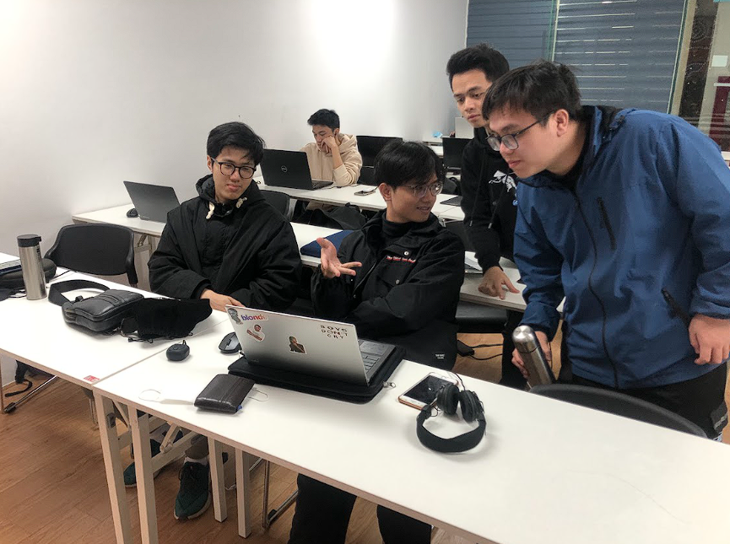

Meeting minutes:

* Vu provided guidance on the database schema for admin features (F6, F7, F8, F9).
* Linh prepared for the mid-sprint review with stakeholders.
* Dat facilitated a quick review of the sprint burndown chart.
* Nam worked on the admin features for adding/removing cars from the site.
* Tung refined the user interface based on Linh's feedback.

## Day 8

## 

Meeting minutes:

* Vu reviewed the security aspects of the admin portal.
* Linh gathered the latest user feedback and shared it with the team.
* Dat encouraged the team to focus on completing tasks in progress before starting new ones.
* Nam implemented the editing functionality for car information.
* Tung optimized the performance of the search feature.

## Day 9

## 

Meeting minutes:

* Vu discussed scaling options for the growing product.
* Linh ensured that the acceptance criteria for all completed features were met.
* Dat prepared for the upcoming sprint review and retrospective.
* Nam worked on the API for admin to view user information (F8, F9).
* Tung conducted cross-browser testing for the search feature.

## Day 10

## 

* Vu, Linh, and Dat reviewed the sprint's achievements and prepared for the demo.
* Nam finalized the APIs and deployed the latest backend changes to the staging environment.
* Tung completed the front-end work for the sprint and merged changes into the main branch for deployment.